Hall data analysis – 19th July 2019 to 31st Dec 2019 (n=166 days)

Data handling

1. The following variables have been extracted from daily files
   1. CPE files
      1. LED1_P – instantaneous power (converted to W)
      2. LED2_P – instantaneous power (converted to W)
      3. LED3_P – instantaneous power (converted to W)
   2. Socket files
      1. vRELAY1_LVL – instantaneous power (W)
      2. AC_Day_Energy_Session – cumulative daily energy consumption (Wm)
2. Once the data is extracted, data is analysed to obtain
   1. Hourly mean for instantaneous power is calculated by taking mean value for each hour. For a day, 24 hours have been defined as 00:01-01:00, 01:01-02:00 and so on.
   2. Hourly totals from AC_Day_Energy_Session values. The data per day is first analysed to reset the value to 0 at the 0th hour of every day and then calculate the cumulative energy consumption from there. The hourly total is calculated as the last value recorded for a given hour.
3. Next, the data is analysed to assess the quality of data collection by obtaining the missing hours of data collection per day for each of the above variables. The below plots (fig. 1) show the total number of hours for which CPE and sockets data is obtained for each variable per day i.e. 24 hours period, for each month.

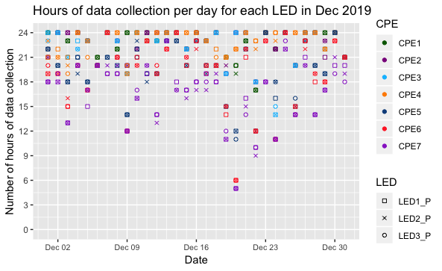

Fig. 1: Total hours of data collection per day for each CPE LED and socket for each month – Jul-Dec 2019. The figure shows gaps in data owing to missing hourly mean values for different parameters.

1. Handling missing data for instantaneous power – It is crucial to replace the NA values for missing hourly data in order to calculate net hourly, daily and monthly energy consumption. To do so, we calculate the typical day profile in a month. A typical day profile is obtained from determining hourly mean (e.g. 1 a.m. to 2 a.m.) values for every day and taking the average values for a day in a month. For estimating this average value, we skip the NA values. The typical hourly values are then used to replace the missing hourly values. Fig. 2 shows the typical day profiles for power consumption for CPE and sockets for each month.

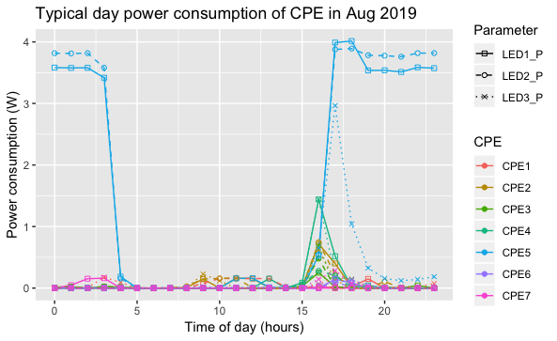

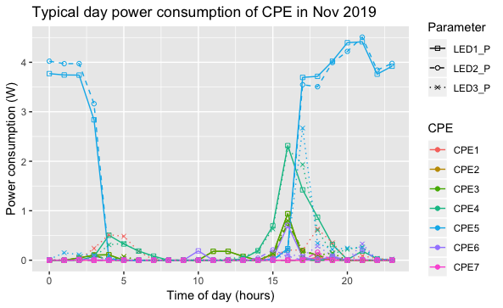

Fig. 2: Typical day profile for power consumption by each CPE and socket for all months.

1. Analysing full dataset to calculate total hourly usage – The missing hourly values are added for each date. The full dataset is then used for evaluation performed in RQ1. The energy consumption at the sockets and lights is calculated using the instantaneous power values for this analysis.
   1. Hourly total (lights and sockets) power consumption per day at the hall for weekdays and weekends per month.

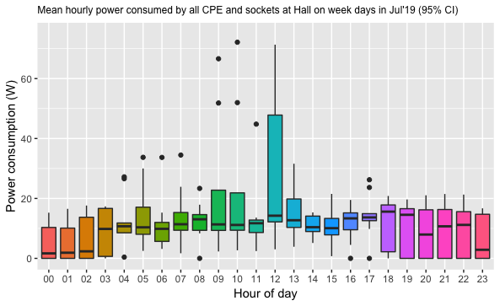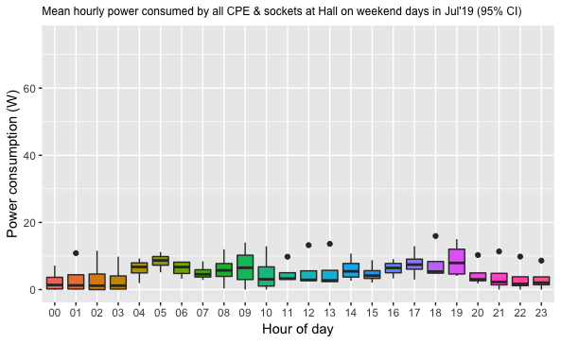

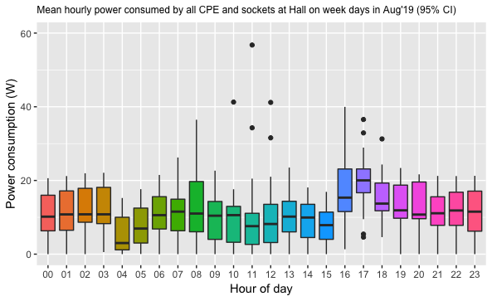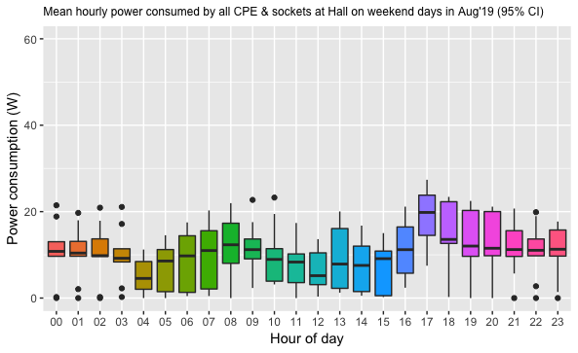

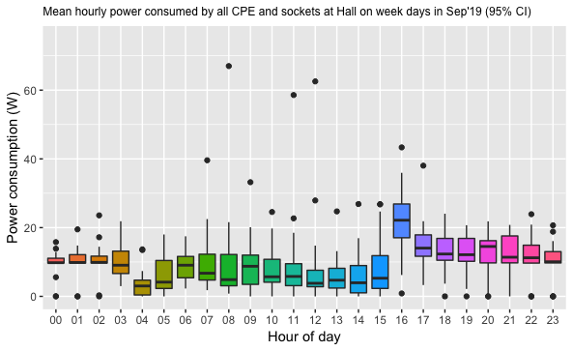

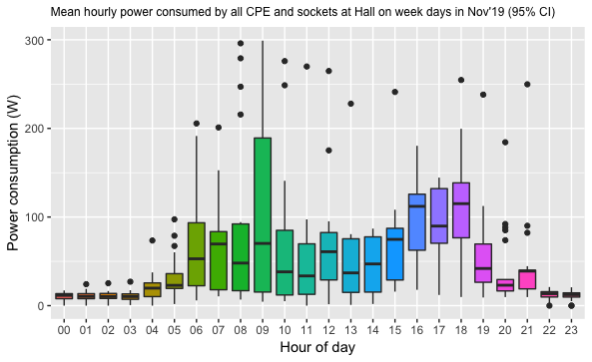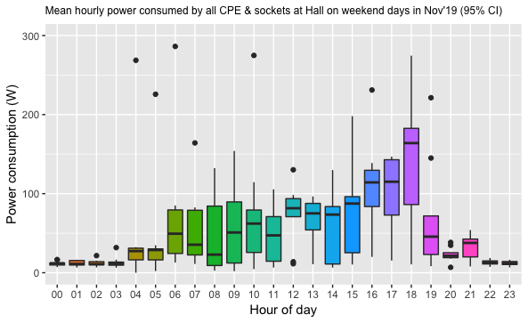

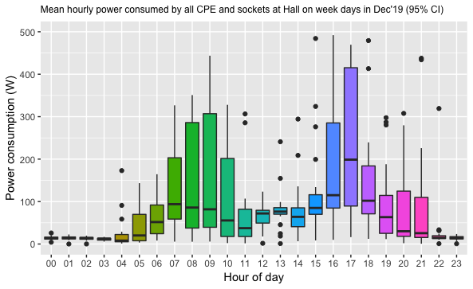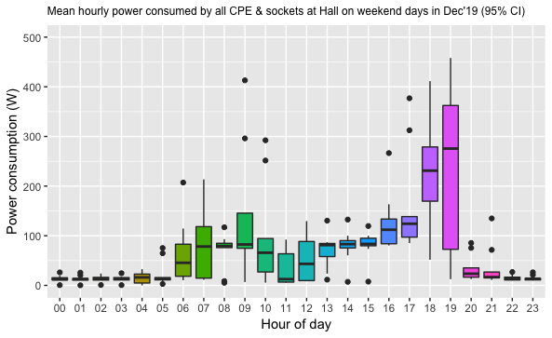

Fig. 3: Mean hourly power consumed by all lights and sockets at the hall per day. The plots have been created for weekdays and weekends for each month to evaluate changes in pattern of use during the two periods.

* 1. Hourly socket power consumption per day at the hall for weekdays and weekends per month.

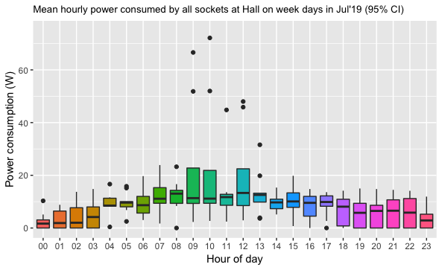

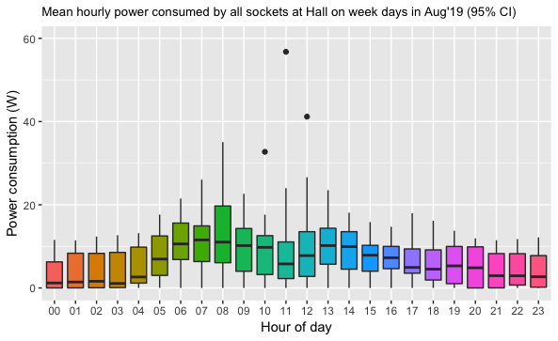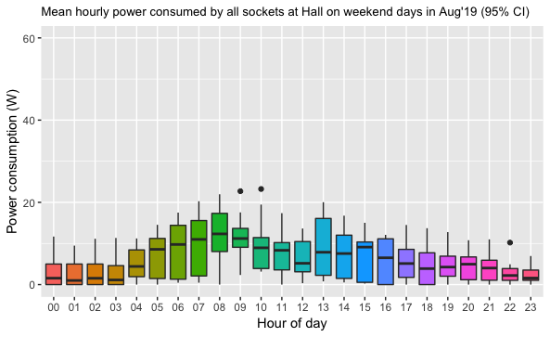

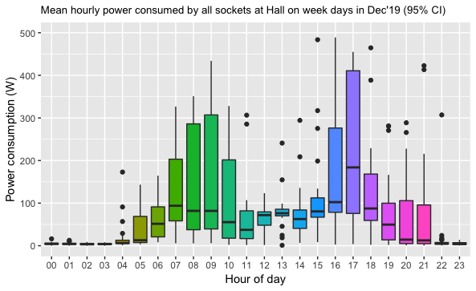

Fig. 4: Mean hourly power consumed by all sockets at the hall per day. The plots have been created for weekdays and weekends for each month to evaluate changes in pattern of use during the two periods.

* 1. Hourly indoor lights power consumption per day at the hall for weekdays and weekends per month.

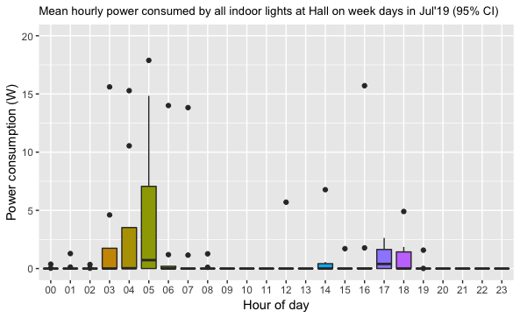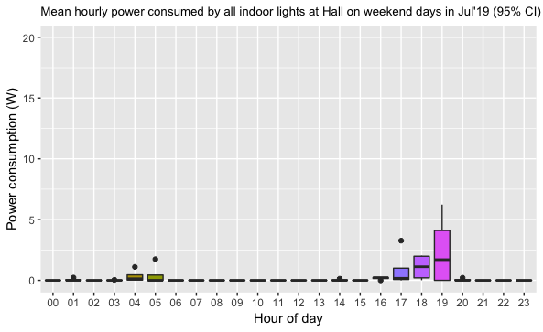

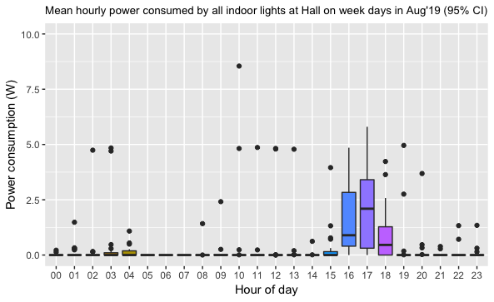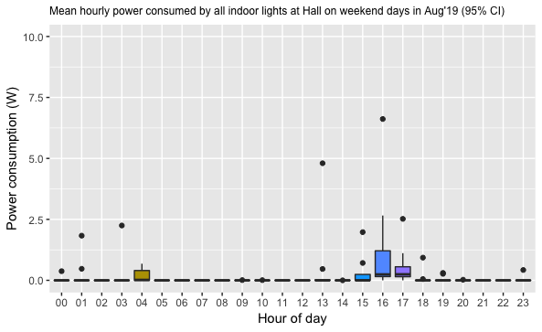

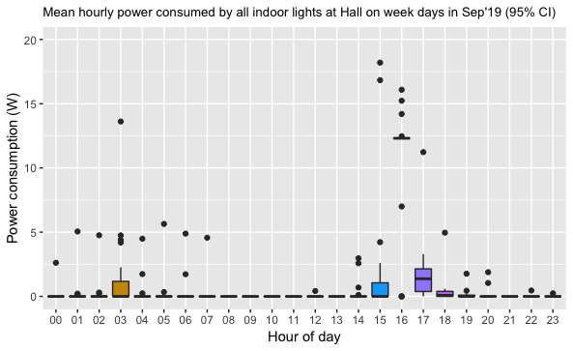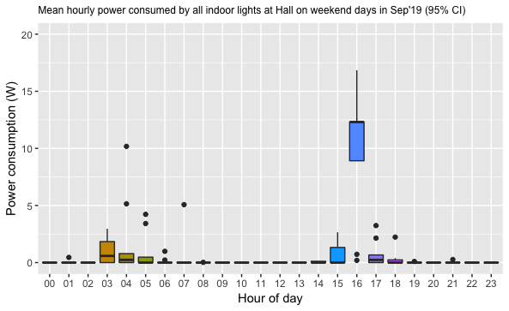

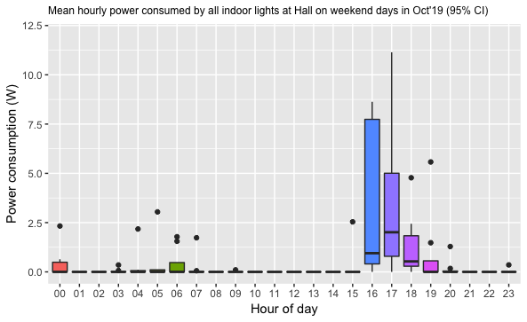

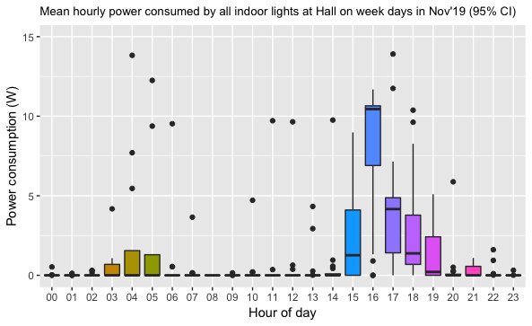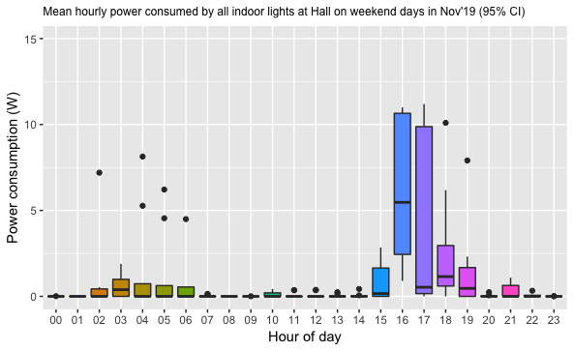

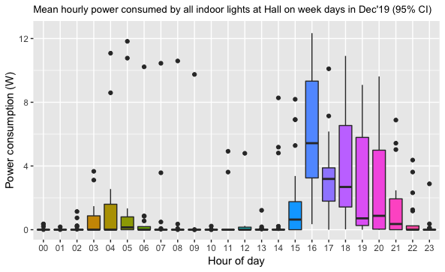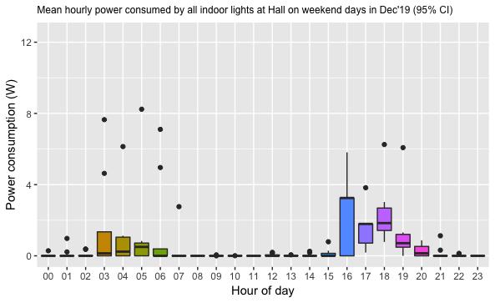

Fig. 5: Mean hourly power consumed by all indoor lights at the hall per day. Of total 7 CPE, 6 of them are indoor lights (all except CPE 5). The plots have been created for weekdays and weekends for each month to evaluate changes in pattern of use during the two periods.

* 1. Hourly outdoor lights power consumption per day at the hall for weekdays and weekends per month.

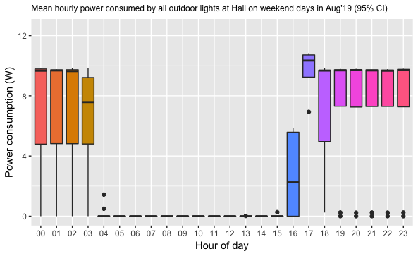

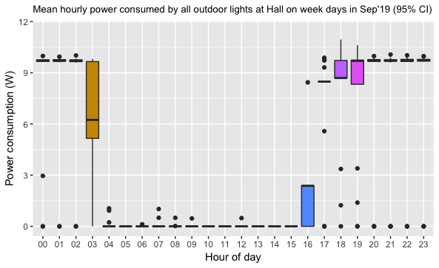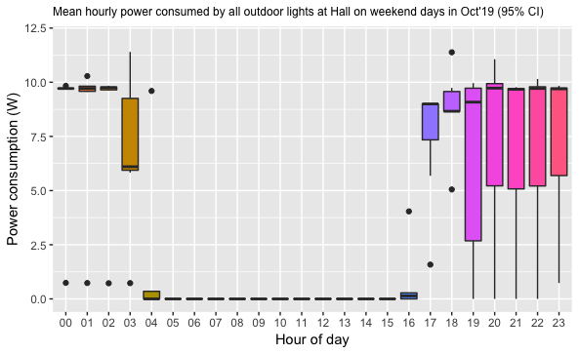

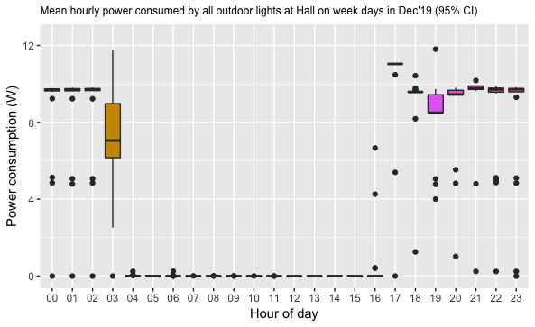

Fig. 6: Mean hourly power consumed by all outdoor lights at the hall per day. Of total 7 CPE, 1 of them (CPE 5) is an outdoor light. The plots have been created for weekdays and weekends for each month to evaluate changes in pattern of use during the two periods.

1. Analysing full dataset to calculate total energy consumption for RQ2 - To see how total energy consumption changes over time, daily total energy consumption of hall per month and total energy consumption since commissioning is plotted. Using these plots, we will be able to see if there has been a growth in energy usage at the hall and how much it has changed over time. The average total daily consumption for each month is also calculated.
   1. Total daily energy consumption for all lights and sockets from Jul to Nov 2019.

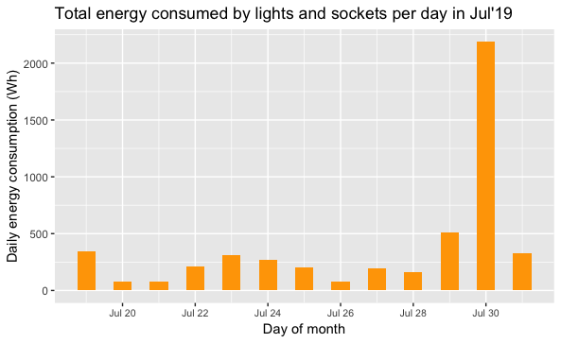

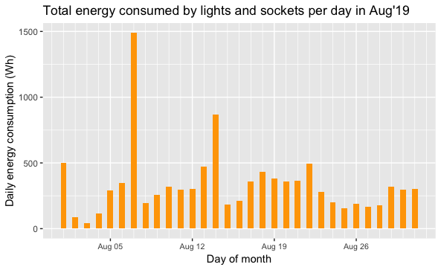

Fig. 7: Total energy consumed by lights and sockets per day for each month between July and Dec 2019.

* 1. Total daily energy consumption by lights and sockets since date of commissioning.

Fig. 8: Total energy consumed by lights and sockets per day since commissioning. The analysis has been performed for a total of 166 days from 19th July 2019 to 31st Dec 2019.

* 1. Average daily energy consumption by lights and sockets for each month.

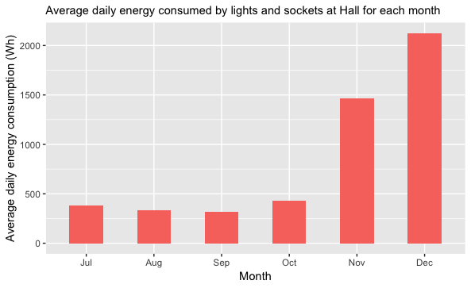

Fig. 9: Average daily energy consumption of lights and sockets at Hall for each month

* 1. Daily energy consumption profile for each user (indoor lights, outdoor lights, S1, S2, S3 and S4) from Jul to Dec 2019.

Fig. 10: Daily energy consumption for each user at the Hall from Jul to Dec 2019.

* 1. Total monthly energy consumption values for the sockets and lights at Nyabiheke hall. The system auxiliary loads are also shown in fig. 11.

Fig. 11: Total monthly energy consumption for each socket and light at the hall. The system auxiliary load is also shown.

1. Analysing data to assess the validity and accuracy of our assumptions and simulations to design and size the system using predicted energy demand profiles and meteorological conditions?
   1. Typical day profiles for each month – the typical day profiles are obtained from determining hourly mean (e.g. 1 a.m. to 2 a.m.) values for every day and taking the average. The plots below (fig. 12) show the potential PV output based on weather data versus the actual PV power output, AC load and battery charge, discharge and state of charge for different times of day.

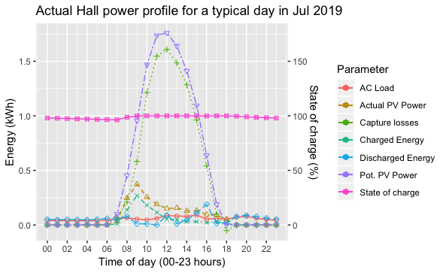

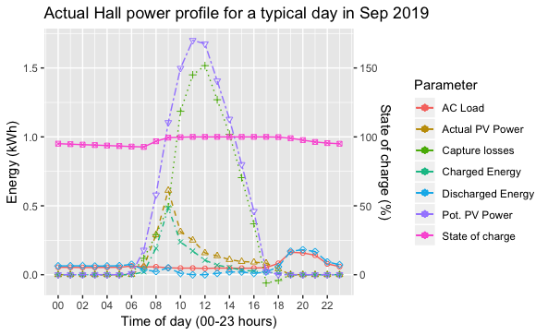

Fig. 12: Typical day profile for system use at Nyabiheke hall for each month. The state of battery charge is also shown on the secondary y axis.

* 1. Capture losses - By creating graphs for an entire yearfor capture losses, we will see how the surplus potential energy from PV panels going to waste changes over time because of variations in energy consumption. As shown in fig. 13, capture losses decrease after the first 3 months as the use of energy at the Hall increases.

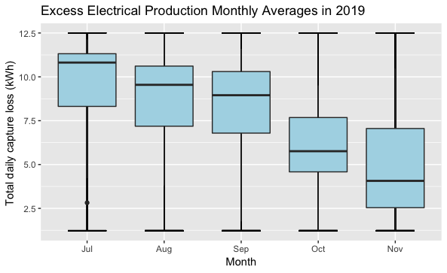

Fig. 13. Daily capture losses (potential PV power output – actual PV power output) for all months of study. As expected, the capture losses decrease with increase in energy consumption in Oct and Nov 2019.

* 1. To investigate further the potential PV power that is not utilised at the hall, the estimated monthly capture and system losses are shown in comparison to the utilised PV power in fig. 14.

Fig. 14: Utilised PV yield, System losses and Capture Losses at Nyabiheke hall for each month. An increase in Utilised PV yield can be seen along with decrease in capture losses with increase in energy consumption over the months.

1. Handling missing data for cumulative energy per day – While the above analysis is based on hourly means of instantaneous power consumption of lights and sockets, it has been realised that the energy session values for sockets and lights are more accurate than the instantaneous power values as they are calculated at the RMU at higher frequency. Although the cumulative power values are approximately the same as session values, the analysis is suggested to be carried out using the session values. The AC_Day_Energy_Session values are cumulative and reset to 0 per day. When the system fails to record data for a few hours, the next energy session value contains the cumulative energy for the missing period even if the next reading is obtained the following day. However, the energy session value does not update if the system is down for a consecutive period of days. For instance, the socket consumption for S3 in Nov cannot be obtained for the 12 day period when no data is obtained. Thus, the following approach can be used to handle missing data
   1. For partially missing data i.e. data missing for few hours of a day – a subset of days of full data collection i.e. days with 24 hourly mean values is obtained. For each day, the proportion of energy consumed per hour is calculated using the hourly and total energy consumption per day. Using these values, the typical proportion/ratio of energy usage per hour for a typical day in month is calculated. Next, the missing hours from the dataset are noted and the difference in consecutive energy session values is calculated. The difference in cumulative energy is then distributed in the given proportions using weighted average for each hour to calculate estimated energy consumption values per hour.
   2. For missing days – the data is to be completely discarded from the dataset.

Moreover, while the instantaneous power is available for each LED (LED 1,2,3) in CPE, only 1 session value is available for all LED combined. While this is ok to be used in case of hall where only CPE5 is outdoors, the same approach cannot be used for Microgrid as the outdoor and indoor lights per CPE need to be separated. A way to resolve this issue needs to be discussed with MeshPower.

**Appendix – Analysis of socket parameters**

Following observations were made upon analysing various parameters for sockets.

1. vRELAY1_LVL == vRELAY1_V * vRELAY1_I * vRELAY1_PF == vRELAY1_VA * vRELAY1_PF == Real power
2. vRELAY1_VA == vRELAY1_V * vRELAY1_I == Apparent power
3. Cumulative sum for hourly mean of vRELAY1_LVL ~= AC_Day_Energy_Session which is the cumulative energy consumed per day.

Fig. 1: Hourly means for real and apparent power consumed at socket S1 on a random day.

Fig. 2 Hourly cumulative energy consumption per day for socket S1 on a random day

1. While calculations of real power using the other parameters should give the same values, a difference in values was observed – perhaps owing to mean taken over instantaneous readings for an hour.
2. The data was also analysed for missing values for different parameters to see if missing values for VRELAY1_LVL or AC_Day_Energy_Session can be replaced using other parameters. It was observed that the periods of missing data are mostly overlapping for all parameters as shown in fig. 3. A summary of missing data is provided below.

Fig. 3 Missing data for all socket variables for the period of study between 19th July 2019 to 31st Dec 2019. A significant overlap is seen for the missing periods of data collection. The periods include days where 0 hours of data collection was noted as the system was down.

1. Summary of missing data for the socket parameters - Total missing hours of data across a total period of study is 166 days (19th July to 31st Dec). These values include the days for which the system was down.
   1. Voltage - 653 hours over 75 days
   2. Current - 657 over 75 hours
   3. PF - 657 hours over 76 days
   4. VA - 661 hours over 79 days
   5. LVL - 652 hours over 78 days
   6. Energy session - 659 hours over 77 days

Of these, 70 days are overlapping across all variables i.e. data is missing for same 70 days for all variables. Furthermore, the hours of missing data are roughly the same.